The Registrar SRMO-001-00-01
____________________
____________________

Sir/Madam:

This is to request for the issuance of certified copy of:
( ) SF 9 (BPS Form 138-A) ( ) SF 10 (BPS Form 137-A) ( ) Honorable Dismissal
( ) Good Moral Certificate ( ) Diploma ( ) TOR
of the student/s listed below who has/have been considered for temporary admission in
our college.
NAME(S) | GR./YR. LEVEL & SECTION/PROGRAM | SCHOOL YEAR
Note: Please indicate “Copy for City College of SJDM”
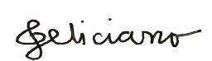
Thank you for your prompt attention.
GUINEVERE S. FELICIANO
Registrar/Administrative Officer V

-----------------------------------------------------------------------------------------------------------------------------------

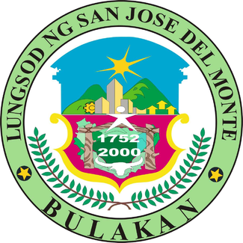
Republic of the Philippines
Province of Bulacan
CITY OF SAN JOSE DEL MONTE
City College of San Jose del Monte
Tel. No. 0917.832.2130 Email: ccsjdm2017@gmail.com
The Registrar SRMO-001-00-01
____________________
____________________

Sir/Madam:

This is to request for the issuance of certified copy of:
( ) SF 9 (BPS Form 138-A) ( ) SF 10 (BPS Form 137-A) ( ) Honorable Dismissal
( ) Good Moral Certificate ( ) Diploma ( ) TOR
of the student/s listed below who has/have been considered for temporary admission in
our college.
NAME(S) | GR./YR. LEVEL & SECTION/PROGRAM | SCHOOL YEAR
Note: Please indicate “Copy for City College of SJDM”
Thank you for your prompt attention.
GUINEVERE S. FELICIANO
Registrar/Administrative Officer V

